**Final Project Proposal**

Your assignment this week is to write a detailed proposal for your final project. In proposing your final, try to address each of the following areas.

Project title: A web-based bike score calculation interface

**Problem / Question**

Applications are ultimately just tools. What problem or question does your application attempt to resolve or grapple with? How does your application speak to this problem/question?

In my capstone project, I used ArcGIS to conduct my bike score calculation. However, as I learned more about geoprocessing on web, I found it more useful than doing it offline as the data can be updated constantly. In addition, web calculation also gives chance for users to modify the weights and customize the scoring based on their need. Therefore, for this project, I hope to create a **customizable bike score calculator web interface**.

**The data**

Geospatial applications are all about working with data. What datasets would you plan/like to use? If the data you'll be working with isn't already stored in a way that you can use, how will you be storing your data?

I have one raster data that I stored in my computer: the slope analysis of Philadelphia. The rest are vector data from opendataphilly.org or PASDA. I am inclined to use APIs in my web application, so that all data would be updated constantly.

1. **Street network** (geoJSON, bi-monthly update)
2. **Bike lane types** <http://gis.phila.gov/ArcGIS/rest/services/Bike_Network_and_Supporting_Datasets/MapServer>
3. **Crashes that involves bikers** <https://services.arcgis.com/fLeGjb7u4uXqeF9q/ArcGIS/rest/services/Collisions_crash_2011_2014PUBV/FeatureServer/0/query>
4. **Intersection controls** [https://services.arcgis.com/fLeGjb7u4uXqeF9q/arcgis/rest/services/Intersection_Controls/FeatureServer/0/query?outFields=*&where=1%3D1](https://services.arcgis.com/fLeGjb7u4uXqeF9q/arcgis/rest/services/Intersection_Controls/FeatureServer/0/query?outFields=*&where=1%3D1)
5. **Streets poles** (geoJSON, update as needed)
6. **Bike rack locations** (my own storage)
7. **DVRPC bike count** (updated nightly <http://arcgis.dvrpc.org/arcgis/rest/services/Transportation/BicycleCounts/FeatureServer/0> )

**Technologies used**

Which technologies covered in class (or discovered on your own!) do you plan to use? How do you anticipate using each of these technologies?

Review the APIs/online examples of leaflet, turf, jQuery, underscore (or any library not explicitly covered in class) for functions/uses which you'd like to explore. Briefly describe how you might use them.

Leaflet (I might also consider using google map api), turf, jQuery, underscore, ArcGIS rest API etc.

**Design spec**

**User experience**

At a high level, how do you expect people to use your application?

* Who are the users?
  + Bikers in Philadelphia
  + City planners
* What do they gain from your application' use?
  + Bikers: get an idea of where is good for biking
  + City planners: get an idea of where to prioritize bike infrastructure improvement
* Are there any website/application examples in the wild to which you can compare your final?
  + So far I can think of Esther Needham’s capstone project, which involves user’s customization <https://eneedham.github.io/refugee_resettlement/>

**Layouts and visual design**

So far, we've built all our applications with a side bar for representing non-map content and navigation. This is not the only successful design. Extra content could be displayed in a top bar, through modals, through side bars on both sides, and any combination of these as well as a number not mentioned. Try to describe your application's visual layout. Conceptually (no need for extensive CSS here), what will this design require?

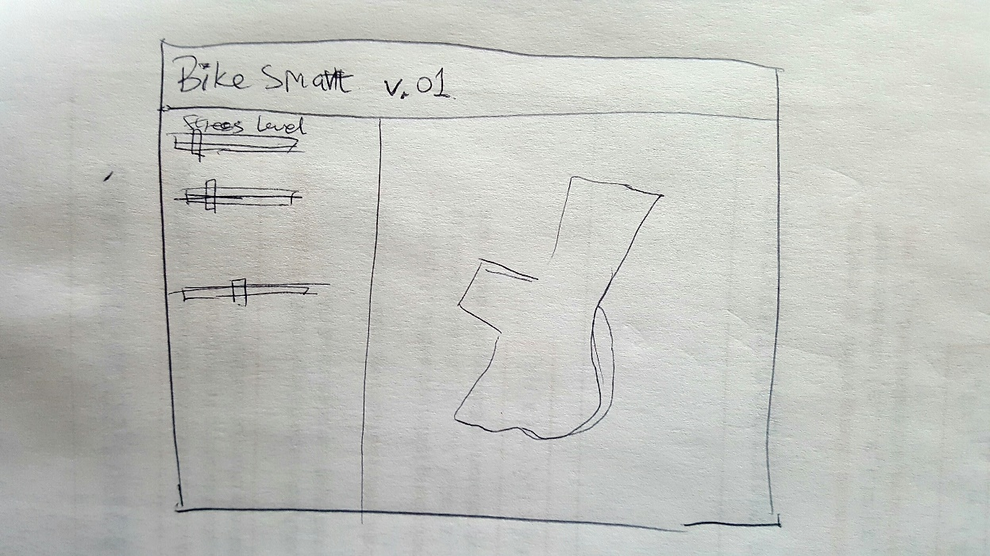

This design will have a top bar, showing the title of this project, and then a side bar and a map. I am open to other layouts as well, but this is what I can think of right now.

**Anticipated difficulties**

Thinking about weaknesses can be useful. What do you anticipate being most difficult about this project? How will you attempt to cope with these difficulties? For example, asynchronous behavior (ajax, events) are hard to use and think about. Global variables are a strategy for coping with that difficulty by breaking data out of the asynchronous context.

I think using Google Map API instead of leaflet might be difficult, because I have to learn it myself. In addition, conducting geospatial analysis on the fly might be challenging to me because I have never done it before.

**Missing pieces**

We've only managed to scratch the surface of the available technologies by which you could construct an application. What use-cases haven't we covered that you think would be useful? What technologies not covered seem exciting to you (you don't necessarily have to fully understand what they're for, this is a chance for you to get our help interpreting a technology's purpose/usage).

Connecting this project’s work to my capstone project may be challenging.